Python Installed

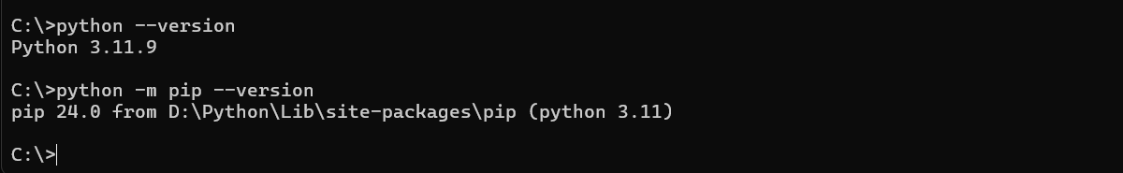

Django Installed

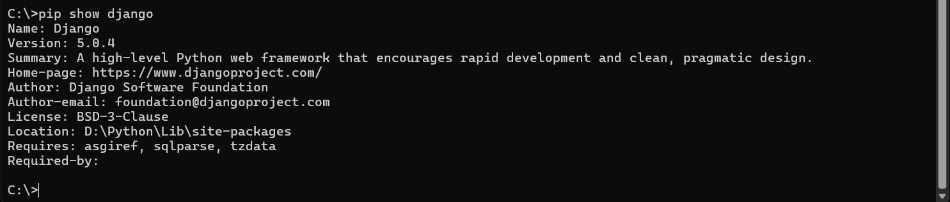

To run on chrome, run this command on command prompt:

D:\Django Project\REGISTRATION SYSTEM\registration>python manage.py runserver